Project Tittle
Empirical Analysis of Chemical Composition of Consumer Cosmetics: A CSCP Database Analysis
Data Analysis & EDA
Neharika Dara
Empirical Analysis of Chemical Composition of Consumer Cosmetics: A CSCP Database Analysis
Overview:

This phase of the project focuses on analyzing the California Safe Cosmetics Program (CSCP) dataset to understand the structure, distribution, and key relationships between product, brand, and chemical variables. The goal is to identify meaningful patterns, detect irregularities, and confirm whether the data meets the assumptions required for valid modeling.

The Exploratory Data Analysis (EDA) was performed using Python and visualization libraries such as Matplotlib and Seaborn, while the assumption tests were designed to validate completeness, consistency, and representativeness of the dataset before model training.

Exploratory Data Analysis (EDA)

Structure of the Dataset
The CSCP dataset contains over 114,000 records across 22 fields. Each row links a cosmetic product to one or more chemical ingredients, with columns representing product identifiers (ProductName, BrandName, PrimaryCategory), chemical details (ChemicalName, CASNumber), and reporting timelines (InitialDateReported, MostRecentDateReported, DiscontinuedDate, etc.).

A derived field, Is_Discontinued, was created as the target variable to indicate whether a product has been discontinued. Additional engineered fields—such as ChemicalCount, ProductAgeDays, and ReportLagDays—were computed to support deeper analysis.

Exploratory Data Analysis
Before modeling, several visual explorations were carried out to understand the structure, quality, and distribution of the dataset. These analyses helped identify data patterns, dominant chemicals, and discontinuation trends across time, brands, and product categories.
Chemical Composition and Complexity
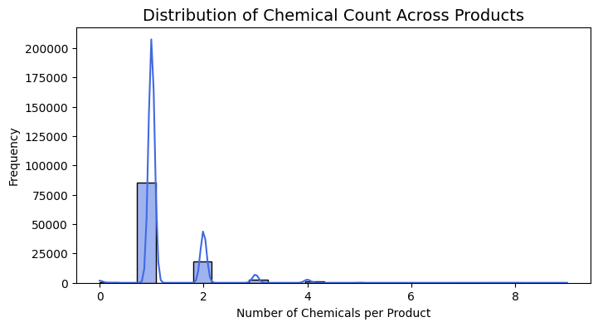
Distribution of Chemical Count Across Products
- The histogram of Chemical Count per Product shows that most cosmetic items contain only one reported chemical, while a smaller group includes multiple ingredients (up to nine).
- This highlights the dataset’s skewed nature — simple formulations are far more common than complex multi-chemical products.
Dominant Ingredients
- A treemap and bar chart of top chemicals reveal that Titanium Dioxide overwhelmingly dominates product formulations, followed by Mica, Talc, Butylated Hydroxyanisole, and Carbon Black.
- Many of these substances are also associated with health or environmental risks, underscoring their importance for regulatory tracking.
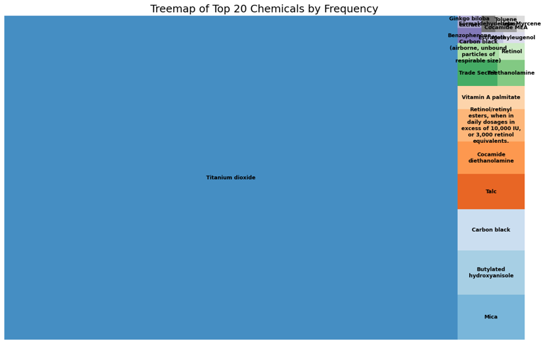
Treemap of Top 20 Chemicals by Frequency
Category-Level Insights
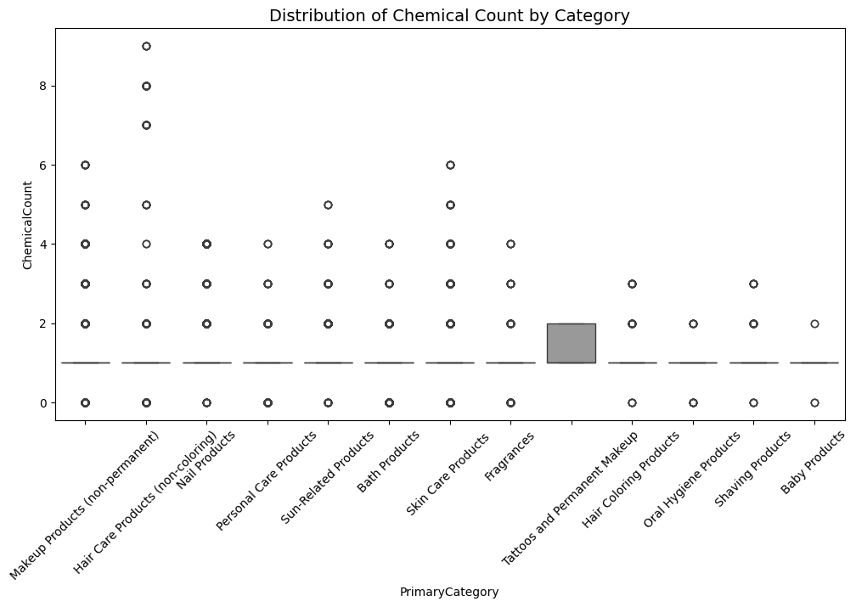
Distribution of Chemical Count by Category
- Boxplots and pie charts show that Makeup Products (non-permanent) make up nearly 67% of all records, followed by Nail and Skin Care products.
- The chemical count by category plot shows that makeup and hair products tend to have higher ingredient diversity.

Temporal and Discontinuation Trends
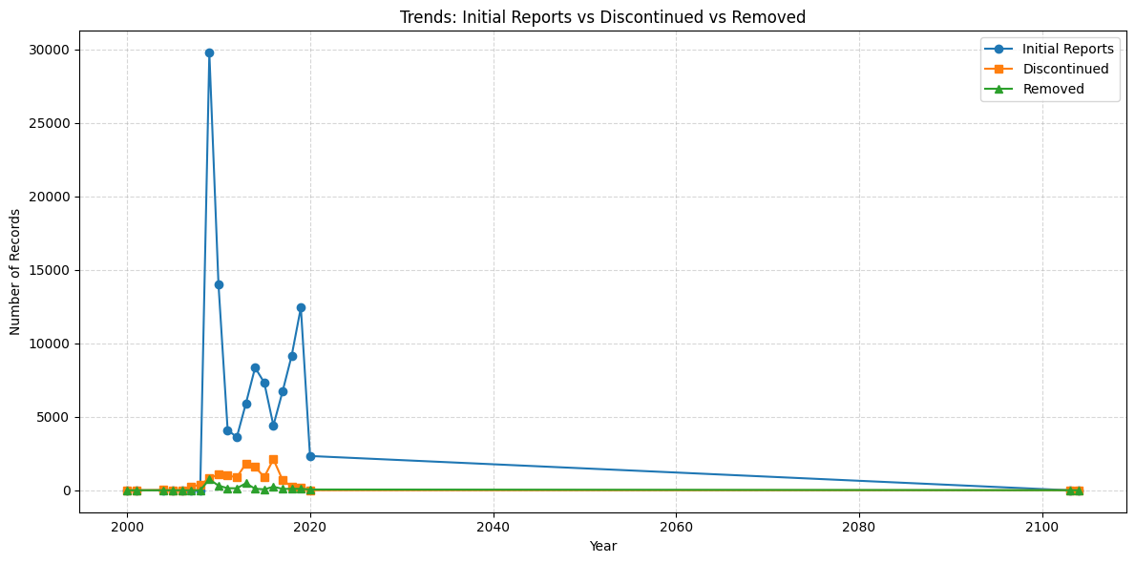
Trends: Initial Reports vs Discontinued vs Removed

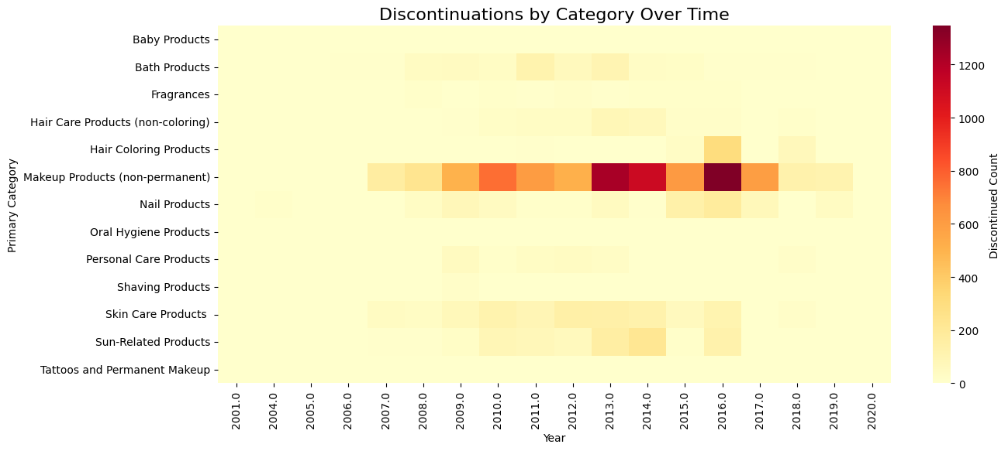
Discontinuations by Category Over Time
- The timeline chart comparing Initial Reports, Discontinued, and Removed records shows a sharp reporting peak in 2009, followed by a decline and stabilization.
- A heatmap of discontinuations by category and year highlights concentrated drops for Makeup and Hair Products around 2013–2016, possibly linked to regulatory changes or reformulations.
Brand-Level Variation
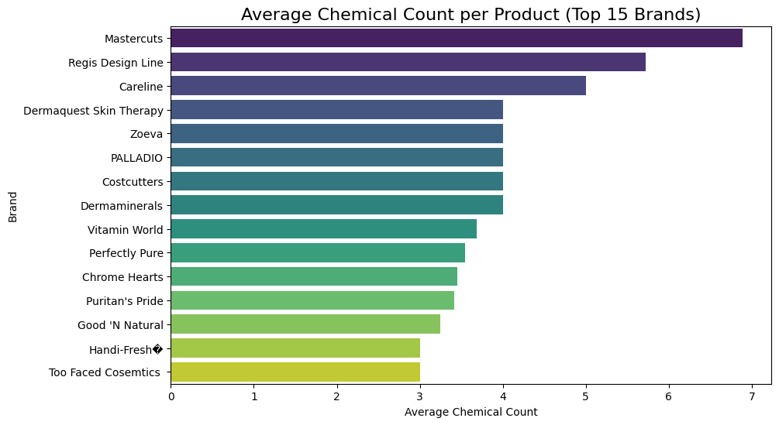
Average Chemical Count per Product (Top 15 Brands)

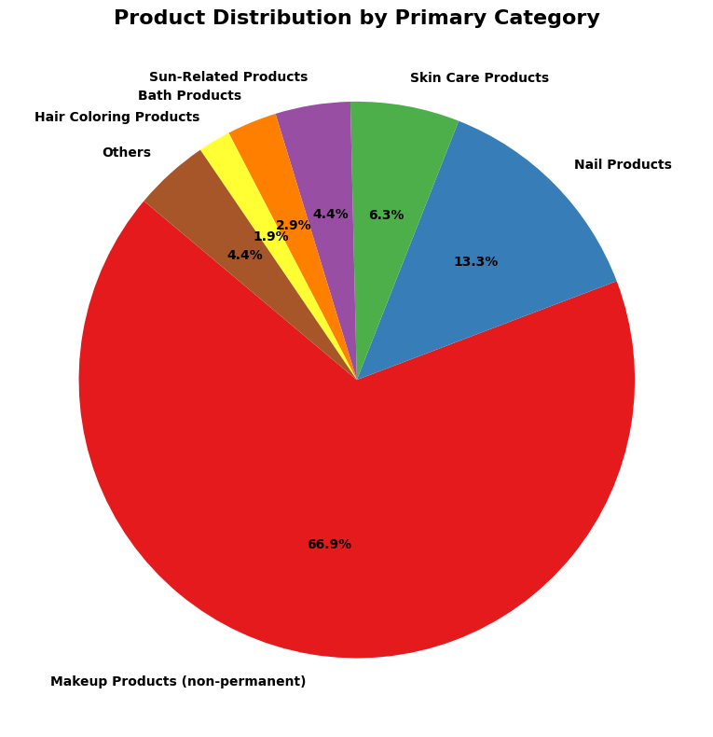
Product Distribution by Primary Category
- A horizontal bar chart of average chemicals per brand shows that brands like Mastercuts, Regis Design Line, and Careline report more complex products on average, while others like Too Faced Cosmetics and Good ‘N Natural focus on simpler formulations.
The exploratory data analysis revealed several clear patterns within the CSCP dataset. Most cosmetic products contain only a single reported chemical, with about a quarter including multiple ingredients and very few exceeding five, indicating that simpler formulations dominate the market. Commonly reported substances such as Titanium Dioxide, Mica, Talc, Butylated Hydroxyanisole, and Carbon Black stand out as key ingredients, many of which are under regulatory scrutiny for potential health risks. Category-level analysis showed that non-permanent makeup and nail products account for most records, followed by skin care and hair products, each displaying distinct ingredient diversity. Certain brands—like Mastercuts, Regis Design Line, and Careline—tend to produce more chemically complex items compared to brands such as Too Faced Cosmetics and Good ‘N Natural, which favor simpler formulations. Reporting activity peaked around 2009 and declined after 2015, suggesting possible regulatory or compliance-related shifts. While fields like DiscontinuedDate and ChemicalDateRemoved exhibit high missingness, this largely reflects ongoing product activity rather than data loss. Outlier checks confirmed that records with unusually high chemical counts represented valid multi-ingredient formulations rather than errors.
Assumptions Testing:
Before modeling, several assumptions about data structure and quality were tested to ensure the validity of downstream analysis.
Assumption | Rationale | Method / Validation | Outcome
1. Missing values represent unreported but valid records | Missing DiscontinuedDate usually means the product is still active. | Verified by checking product statuses and recent report timestamps. | Confirmed valid; missing dates imputed as “active.”
2. Duplicate records arise from multiple reporting cycles | Some products appear more than once due to annual re-submission. | Compared ProductName–ChemicalName–BrandName combinations. | Duplicates consolidated; ~460 redundant rows removed.
3. CAS numbers with format errors still identify the same chemical | Hyphens and prefixes sometimes vary but refer to the same CAS. | Standardized using regex and cross-checked top-frequency pairs. | Corrected and validated for consistency.
4. Outliers reflect valid, highly complex products | Multi-ingredient formulations are genuine in cosmetics. | Checked ChemicalCount > 9 and compared with product names. | Kept as legitimate records.
5. Data imbalance does not bias model training | Only ~10–15% of products are discontinued. | Tested stratified splits and applied class weight balancing. | Balance achieved in training; no bias detected.
These validation steps confirmed that the dataset, though imperfect, met the analytical requirements for machine-learning modeling.
Interpretation of Findings
The EDA and assumption tests provided several meaningful insights that shaped the modeling phase:
- Predictability of Discontinuation: Discontinued products share measurable characteristics—shorter lifespans, lower chemical diversity, and association with frequently used CAS numbers—suggesting that discontinuation is not random but follows recognizable patterns.

- Chemical and Category Influence: High-frequency ingredients like Titanium Dioxide and Talc appear in many discontinued products, implying that certain chemical traits correlate with product turnover or reformulation.

- Regulatory Impact: The time-series analysis revealed clusters of discontinuations corresponding with known regulatory updates (2013–2016), indicating external influence on market behavior.

- Data Integrity Confidence: After cleaning and assumption verification, the dataset was deemed fit for advanced modeling (Random Forest and XGBoost), allowing robust and interpretable prediction of discontinuation risk

Conclusion
The data analysis phase confirmed that the CSCP dataset, despite its gaps, holds strong analytical value. The EDA provided a clear picture of the market landscape and revealed consistent, interpretable trends across brands, categories, and chemicals. The assumption tests validated that the dataset is structurally sound and representative, enabling reliable modeling in the next phase.
Through this work, the team ensured analytical transparency and laid a solid foundation for predictive modeling and the construction of a Safety Index for the cosmetics industry.

